

**UNIVERSITY OF ASIA PACIFIC**

**Department of Computer Science & Engineering**

**Course Title –** Artificial Intelligence and Expert Systems Lab.

**Course Code –** CSE-404.

**Project –** Implementation of a small map (Home - UAP) using A* search ………………………………………………………algorithm.

|  |  |
| --- | --- |
| Submitted by  Shawan Das.  ID – **19101020**  Section – **A**1 | Submitted To  Dr. Nasima Begum  University of Asia Pacific |

**Date of Submission –**  26–09–2022

**Problem Title: Implement small map (From Home to UAP) and find the optimal path using A* Algorithm**

**Problem Description:** Implementation of a small address map from Home to UAP. Find the optimal path using A* Algorithm. A* algorithm is a search algorithm that search for the shortest path between Start node to Goal node.

**Objective:** There are several paths between Puran Dhaka to UAP. All those paths are not optimal path. The objective of this problem is to implement A* search algorithm and find the optimal path from my Home (Puran Dhaka) to UAP.

**Tools & Languages:**

* Diagram.net (Design Road Map)
* Google Map
* Language – Python
* IDE: Google Collab

**Diagram:**

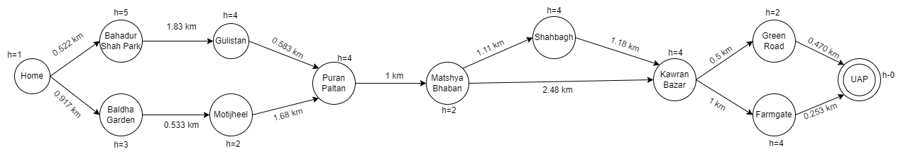

**Google MAP:**

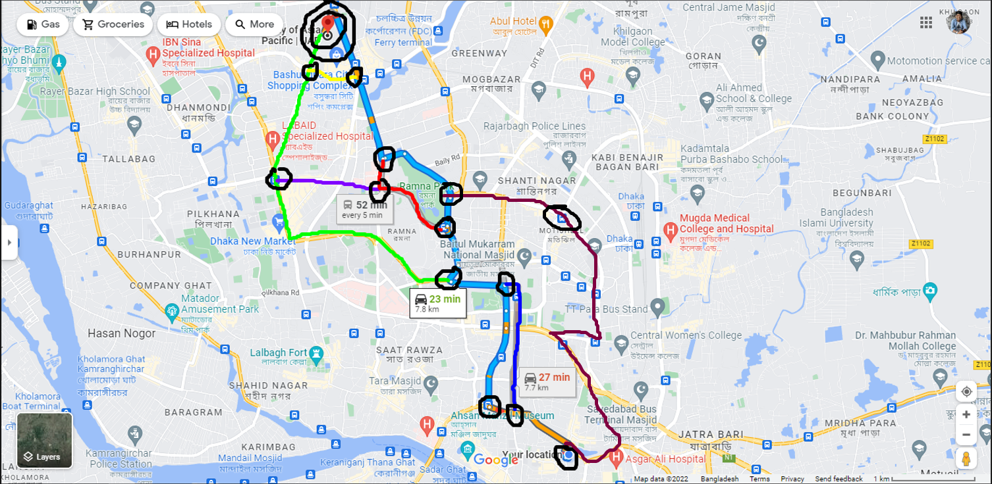

**Heuristic Value:**

* Home - 20 % 4 = 0-> 1
* Bahadur Shah Park - 20 % 15 = 5
* Baldha Garden - 20 % 12 = 8 % 5->3 (8>5)
* Gulistan - 20 % 8 = 4
* Motijheel - 20 % 9 = 2
* Puran Paltan - 20 % 11 = 9 % 5-> 4 (9>5)
* Matshya Bhaban - 20 % 13 = 7 % 5-> 2 (7>5)
* Shahbagh - 20 % 8 = 4
* Kawran Bazar - 20 % 11 = 9 % 5-> 4 (9>5)
* Green Road - 20 % 9 = 2
* Farmgate - 20 % 8 = 4
* UAP - 0 (Destination)

**Search Tree:**

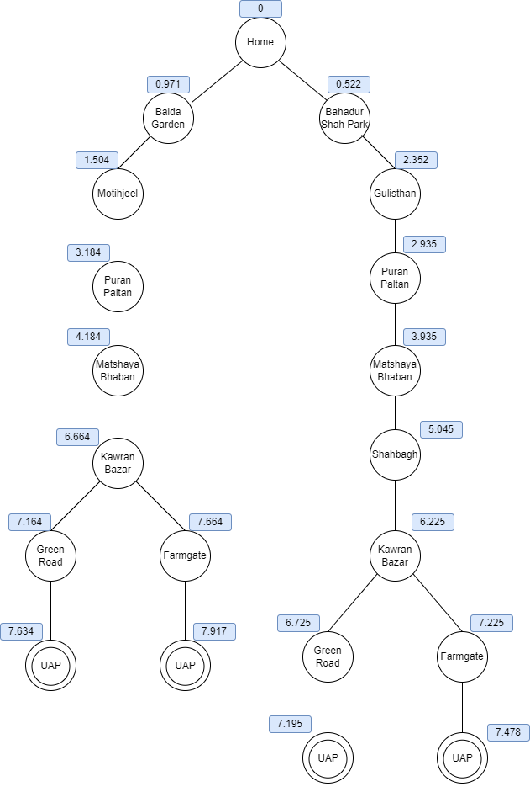

**Shortest Path:**

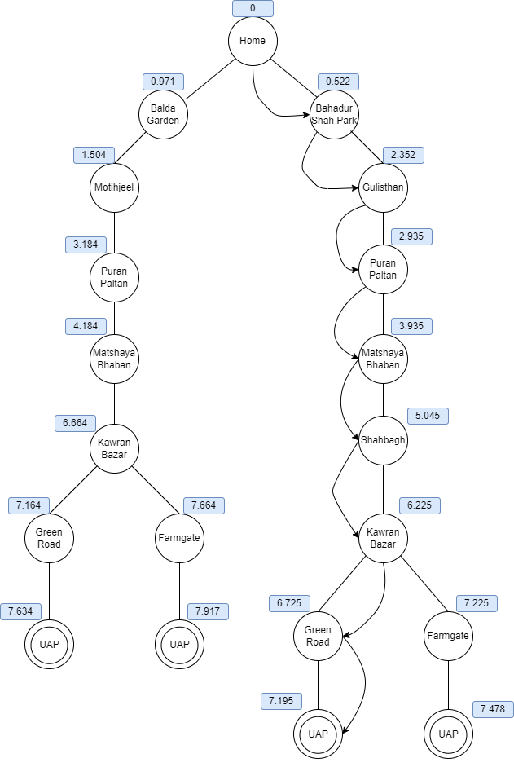



**Source Code:**  [Google Colab](https://colab.research.google.com/drive/1tBqPl9ybOhGvskIwbytotfUt9pWO8LhP?usp=sharing)

**Slide:** [Canva/Road Map](https://www.canva.com/design/DAFNKxCDWuo/m5XxnptK9GJgu8cA9JssRQ/view?utm_content=DAFNKxCDWuo&utm_campaign=designshare&utm_medium=link&utm_source=publishpresent)

**Challenges & Conclusion:**

The main road block for this project was to find out multiple paths. Though I know some roads but I have picked 12 node-point (including Home-node, UAP-node). Then I’ve to use the “measure Distance” feature to calculate the distance. After successful implementation of A* search, I have got the most optimal path as output.

Finally, I can state that A* algorithm is a powerful and beneficial algorithm with all the potential. So, we can use this algorithm for approximate the shortest path in real-life situation, like – in maps, games, robotics etc.